ICP1

Name: Aqdus Charolia

Email: [aacy5x@mail.umkc.edu](mailto:aacy5x@mail.umkc.edu)

Name: Affan Charolia

Email: [aacbb8@mail.umkc.edu](mailto:aacbb8@mail.umkc.edu)

Aim: To Demonstrate the use of GitHub and WebStorm.

Steps/Screenshots:

1. Installation of Webstorm on PC.

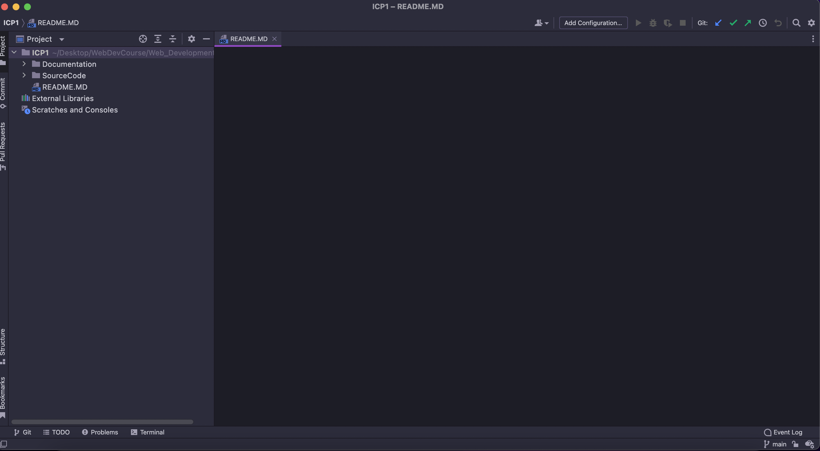

1. Creating Remote Repository on GitHub for the Course.

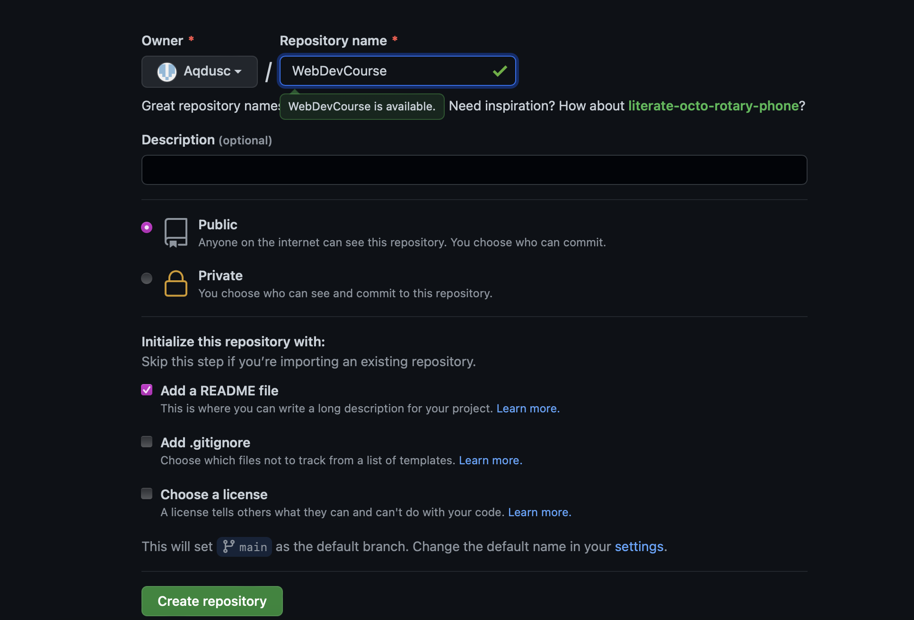

1. Cloning Remote Repository To PC

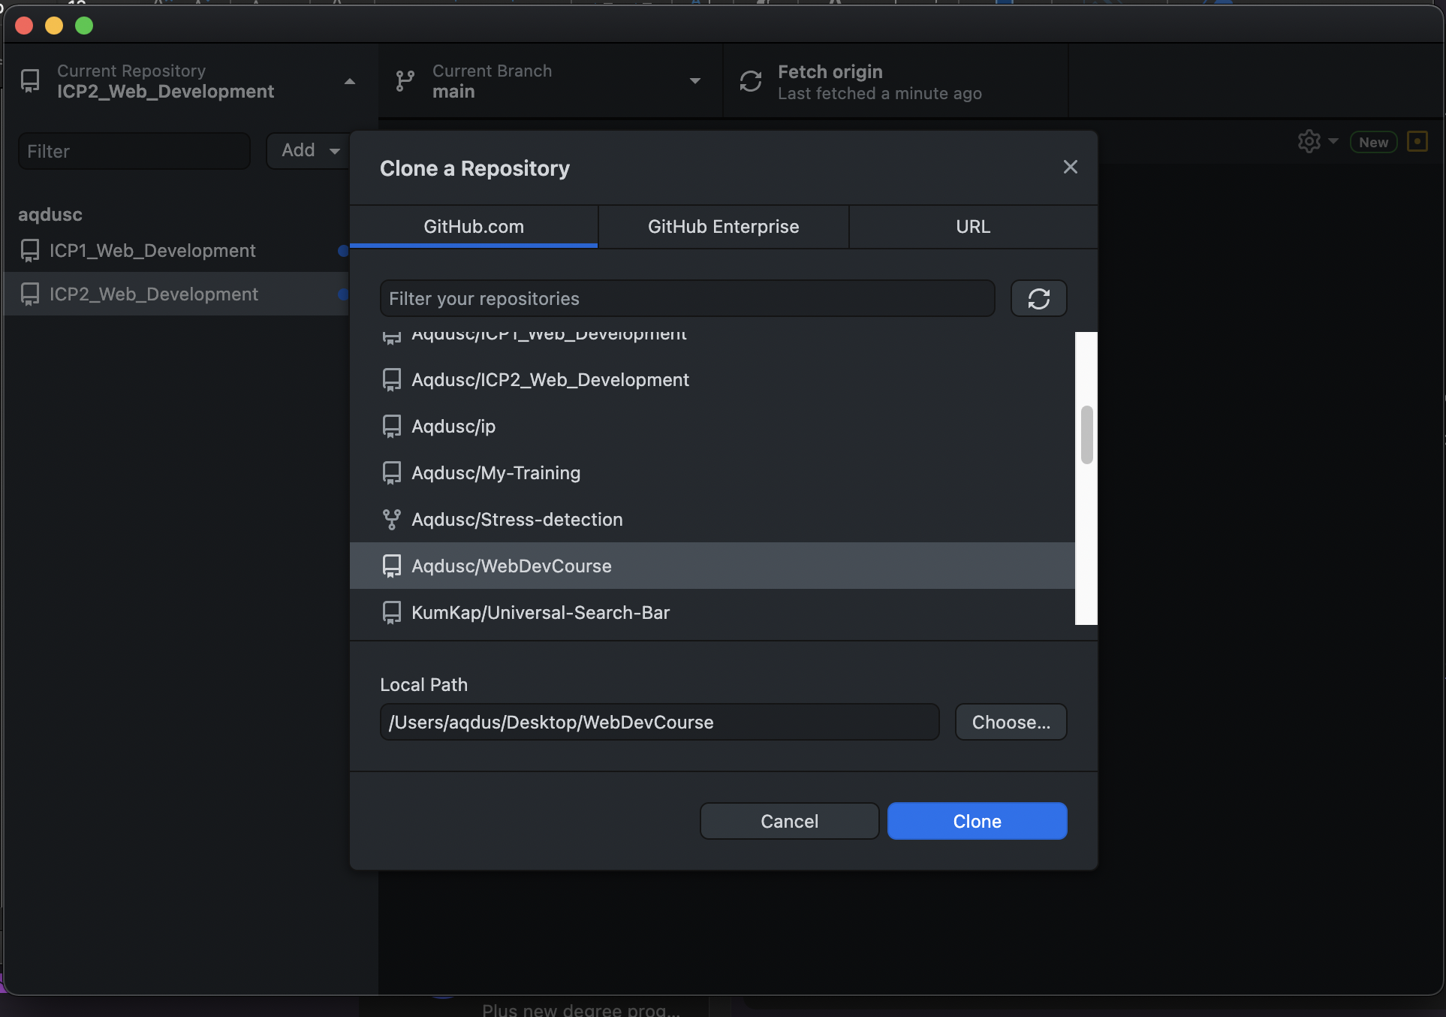



1. Creating Html File in local repository and committing and pushing it

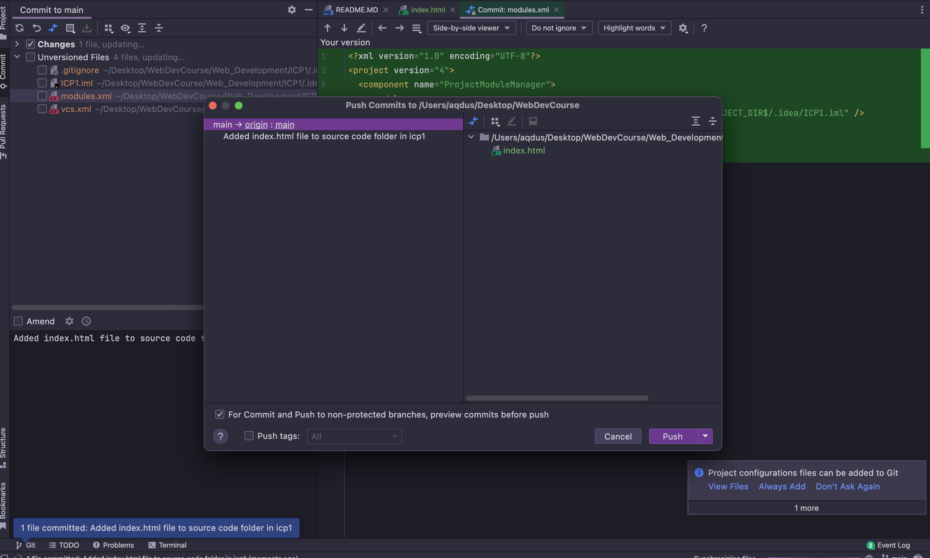

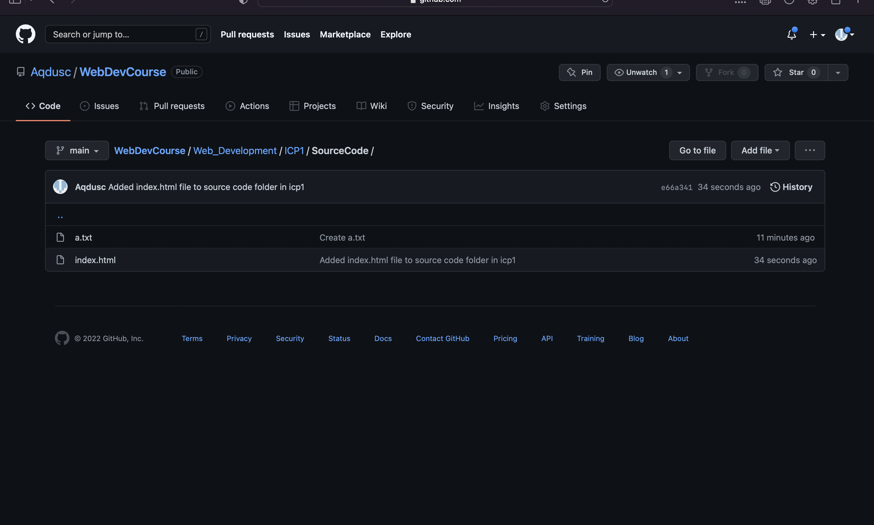

1. Creating a branch to make changes in local repository and syncing to main repository.

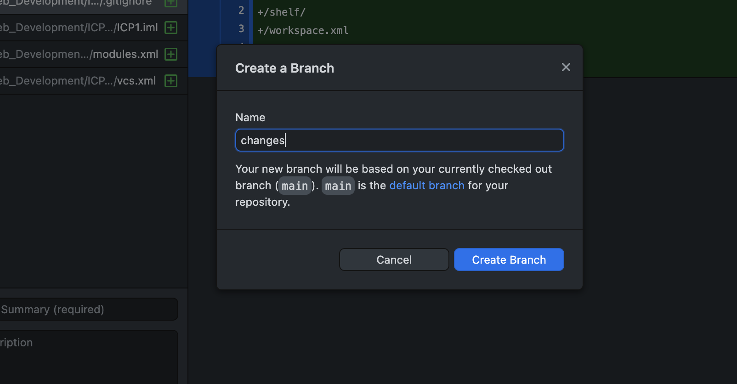

1. Creating a pull request to show changes made in the changes branch, issue is updated HTML File.

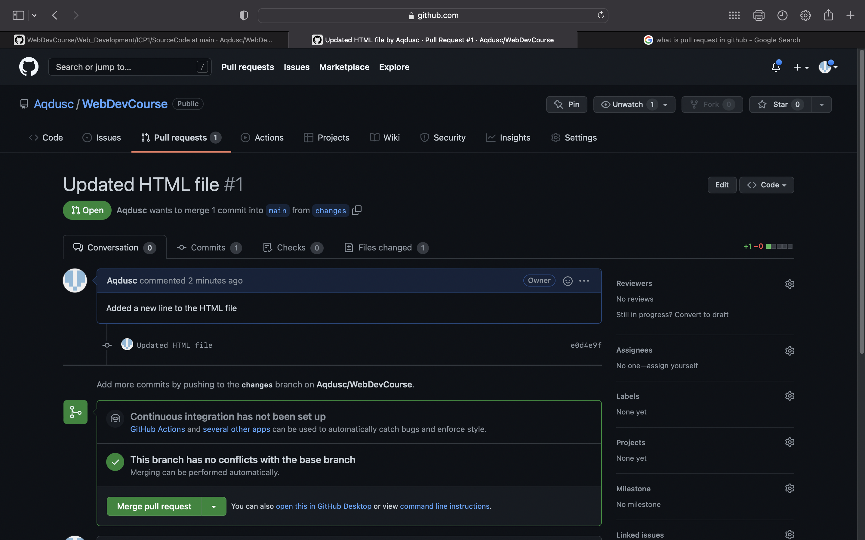

1. Merging the pull request as only change in html file by adding one line.

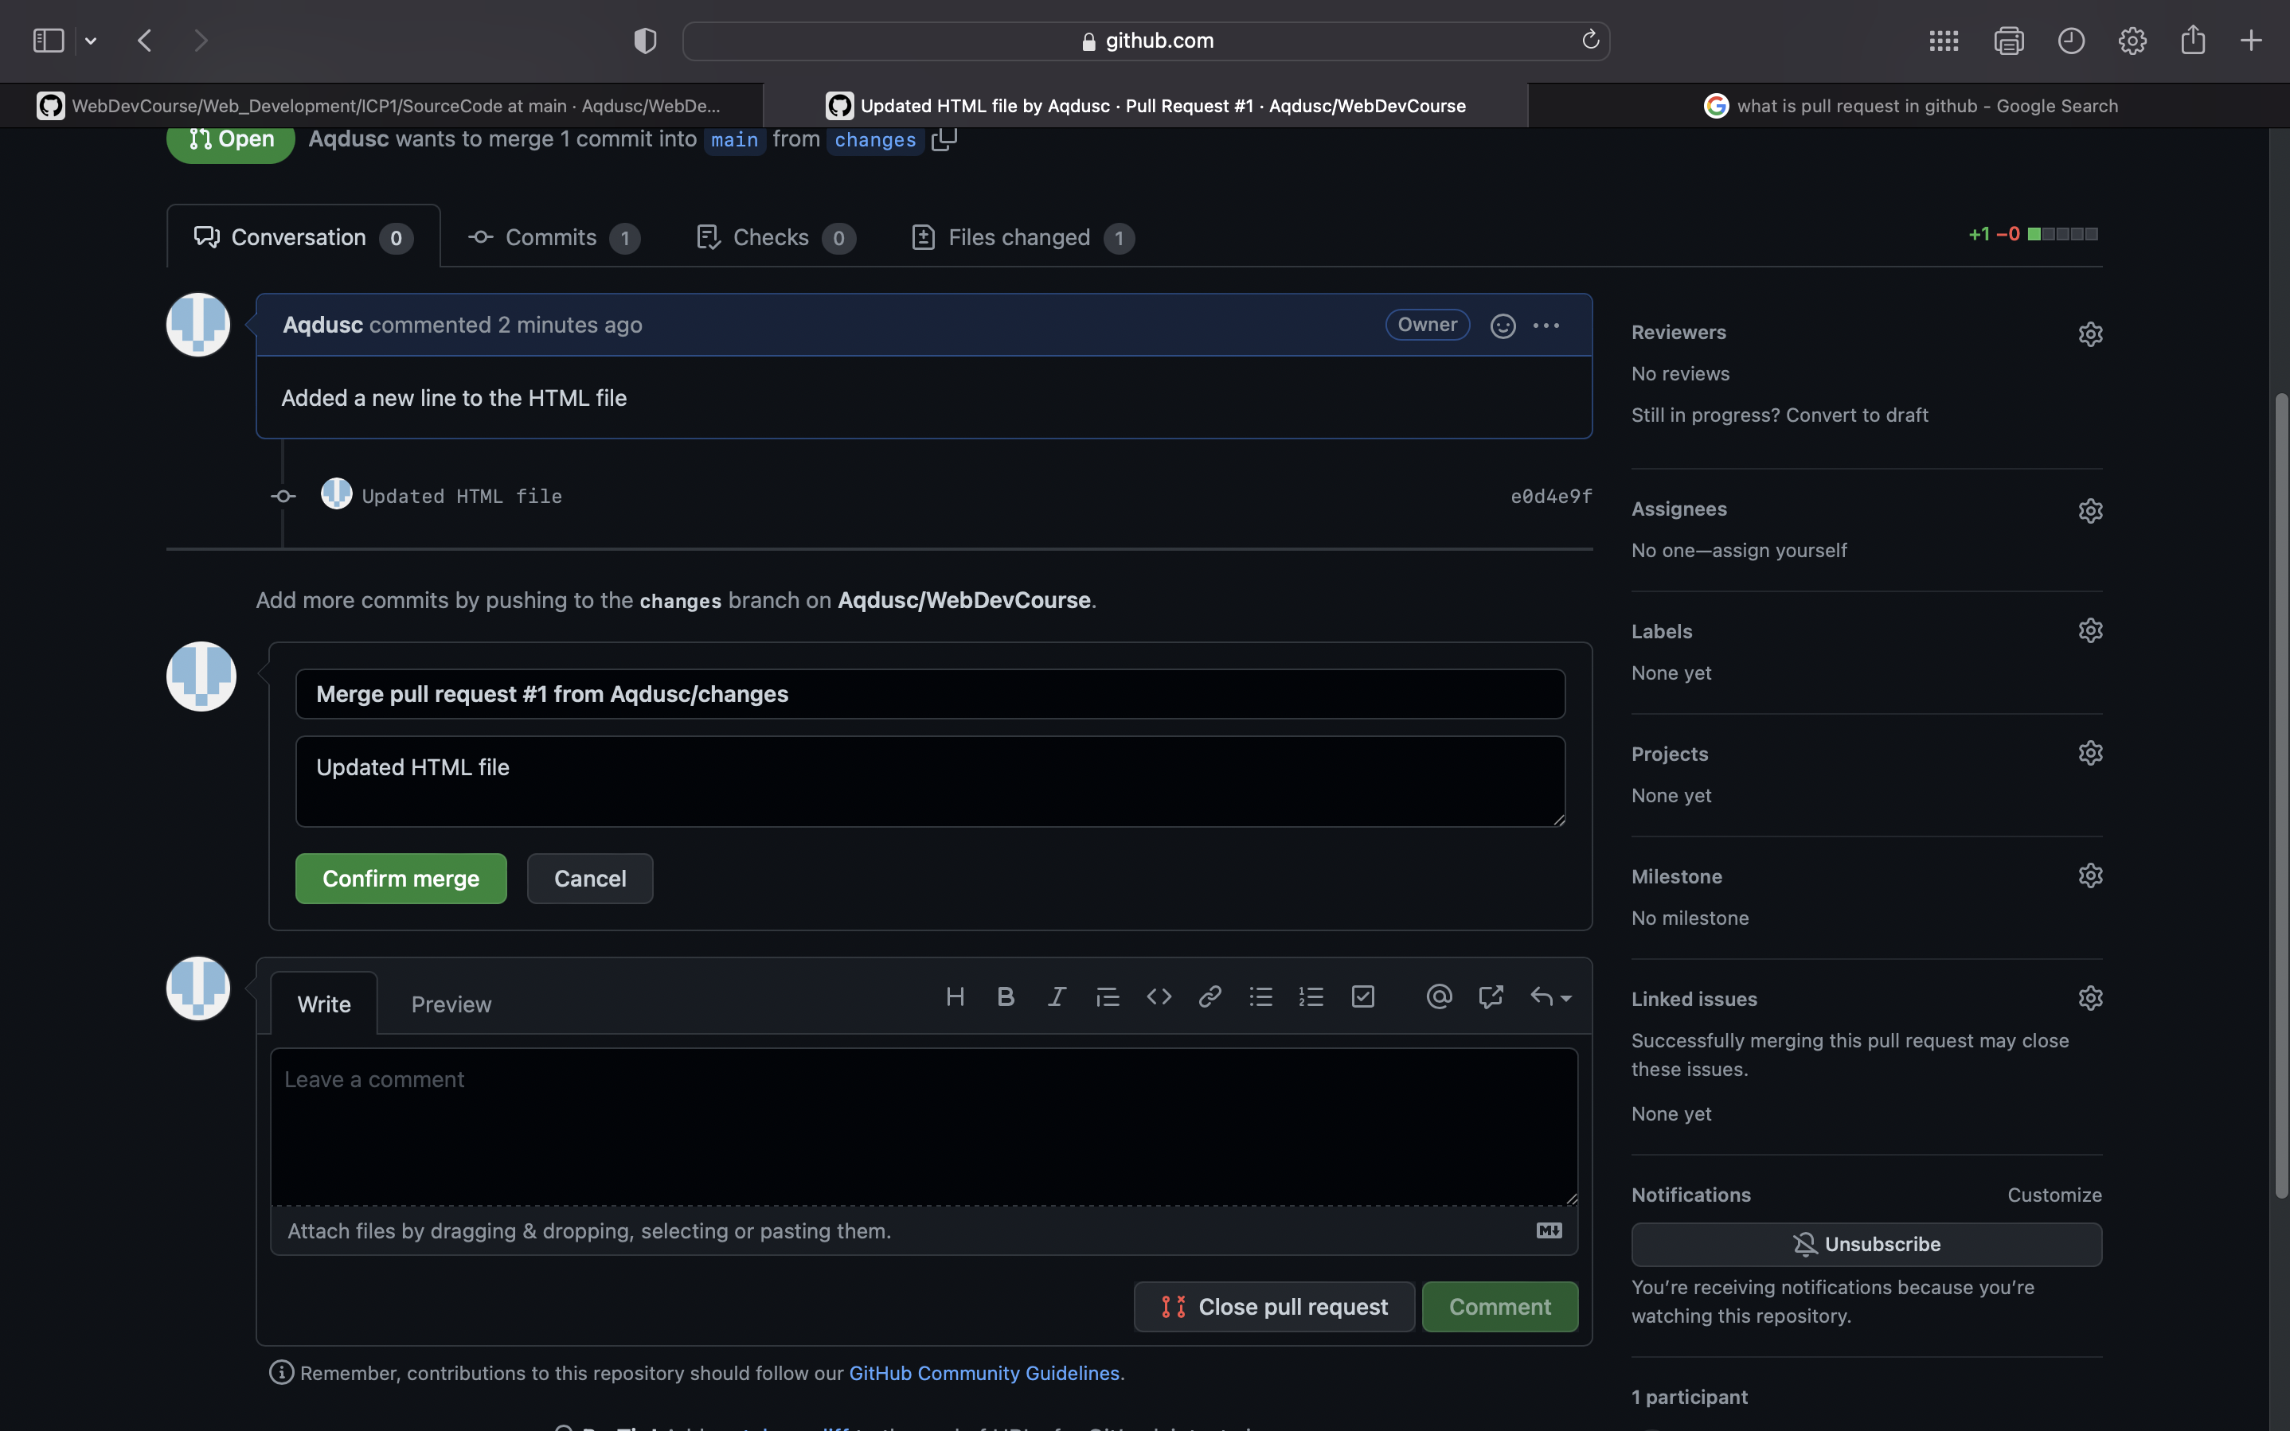

1. Merging the two branchs main and changes into main branch

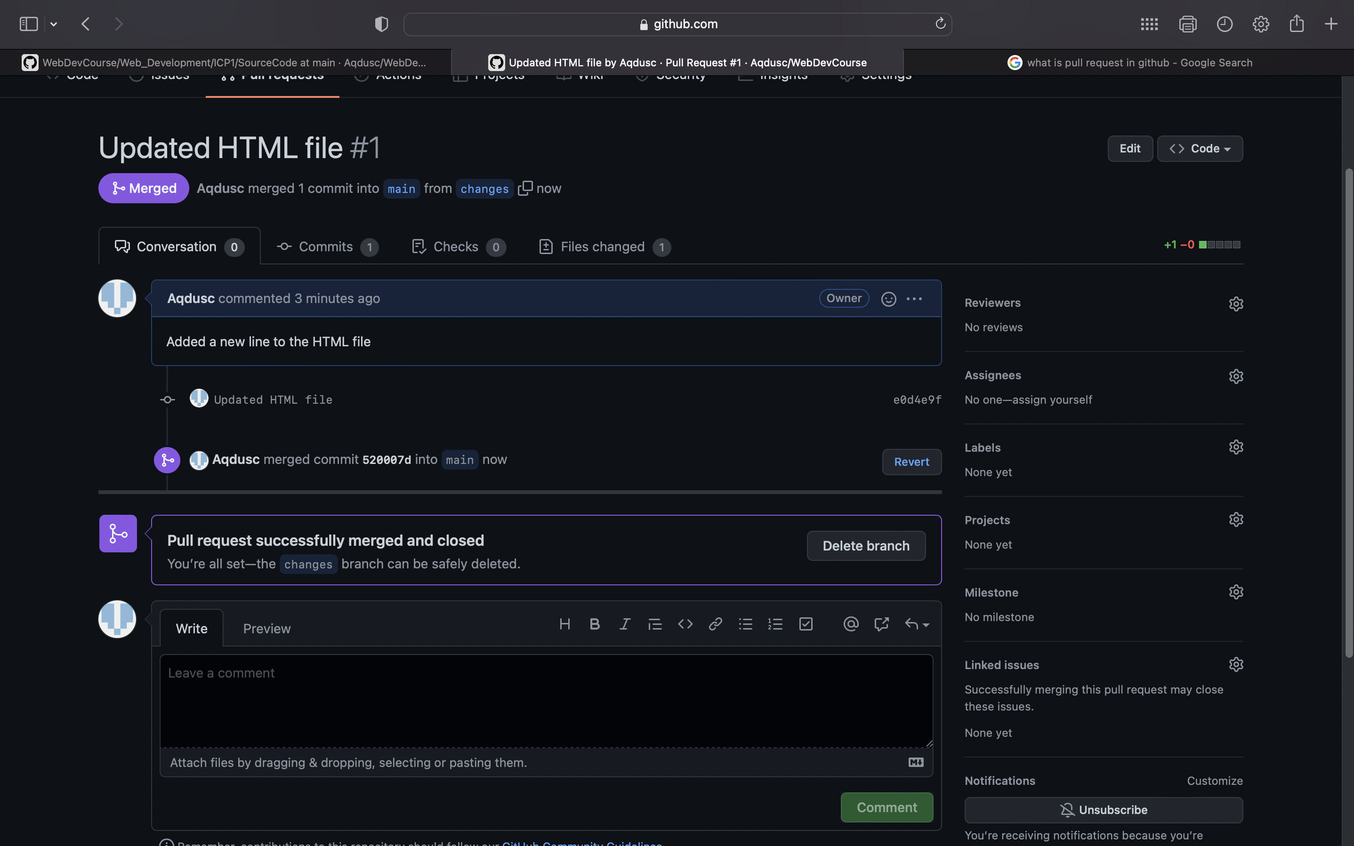

1. Synced all the changes between the local and remote repository/Also added the documentation.pdf file.
2. Forking an existing repository from github.

